**Meditation Helper Website-Project**

1. **Programming Language: HTML, CSS, Javascript:** [**https://github.com/HsuSungTing/Meditation-Helper-Website**](https://github.com/HsuSungTing/Meditation-Helper-Website)
2. **Environment:** 
   1. vs code version

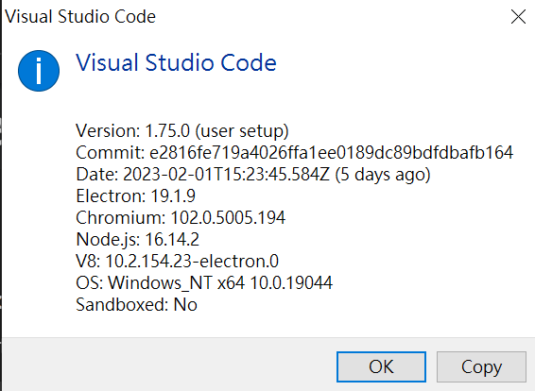

* 1. Live server version



* 1. Xampp version 3.3.0

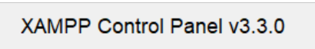

1. **Project Descriptions**
   1. We offer 12 mins Meditation tutorial on page 1, which is a website that enhances and facilitates our meditation skills by playing the media and keeping time.

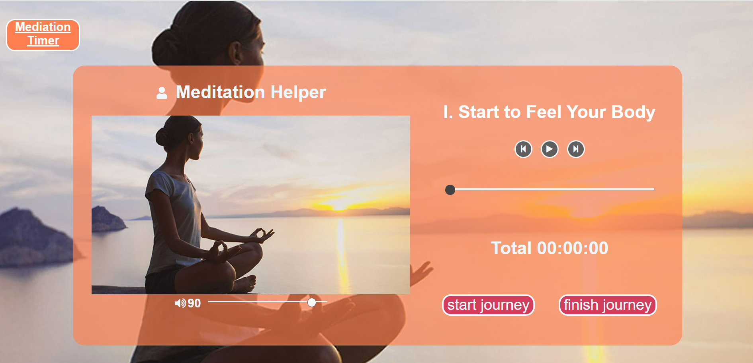

* 1. Page 2 is a Timer helping us meditate better and keep track of our meditation habits.

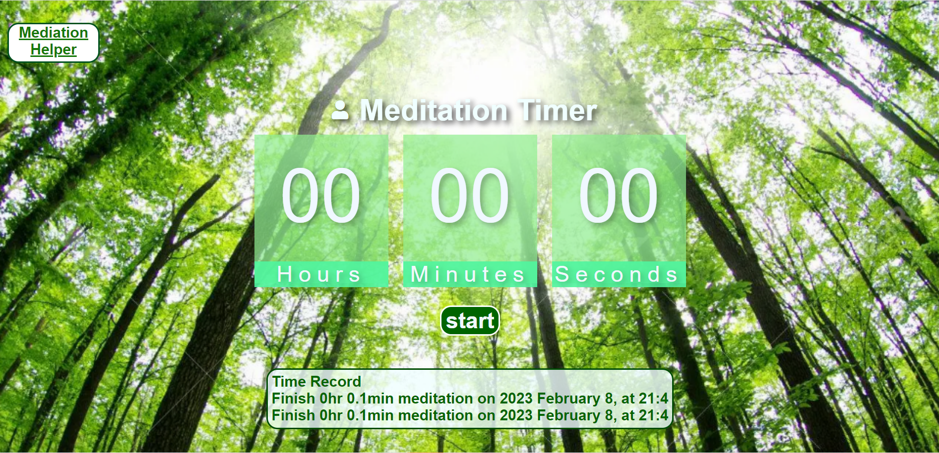

1. **How to run this website on localhost**
   1. Open the Xampp file
   2. Find the “htdocs” file
   3. Put all the files (including .html, .css, .js, images, and .mp3)
   4. Go to the browser(Chrome), and enter the web address of “localhost/filename”.
2. **Features**
   1. **Meditation instructions**: The image will show instructions when the image is clicked.

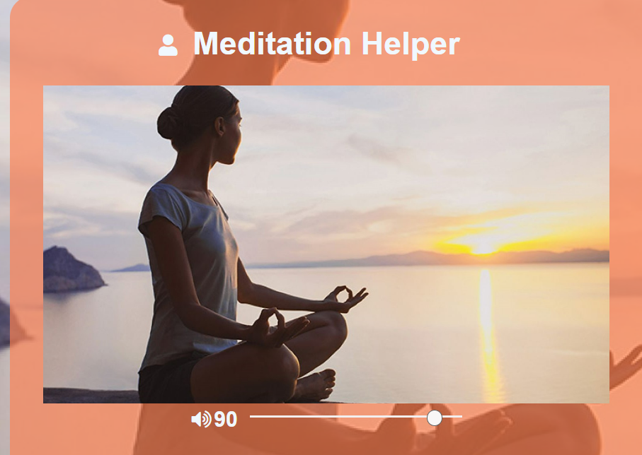 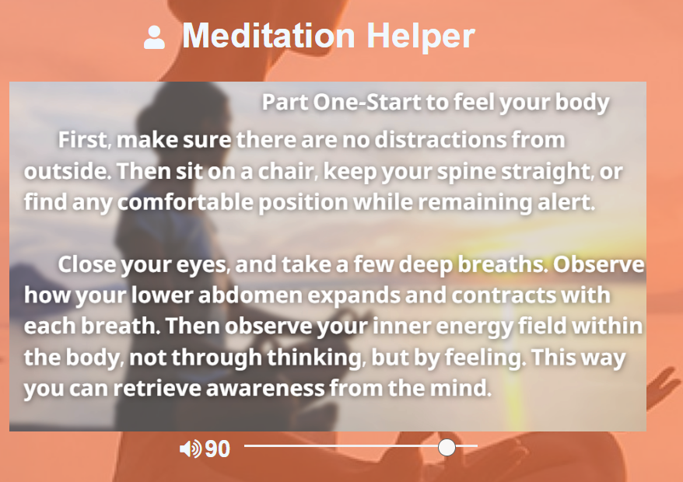

* 1. **Meditation journey** (auto-play the Media): The Media player offers the auto-play function, when the “start journey” button was clicked, the Timer and the horizontal Time bar will be reset, and all three parts of the meditation tutorial will be played.

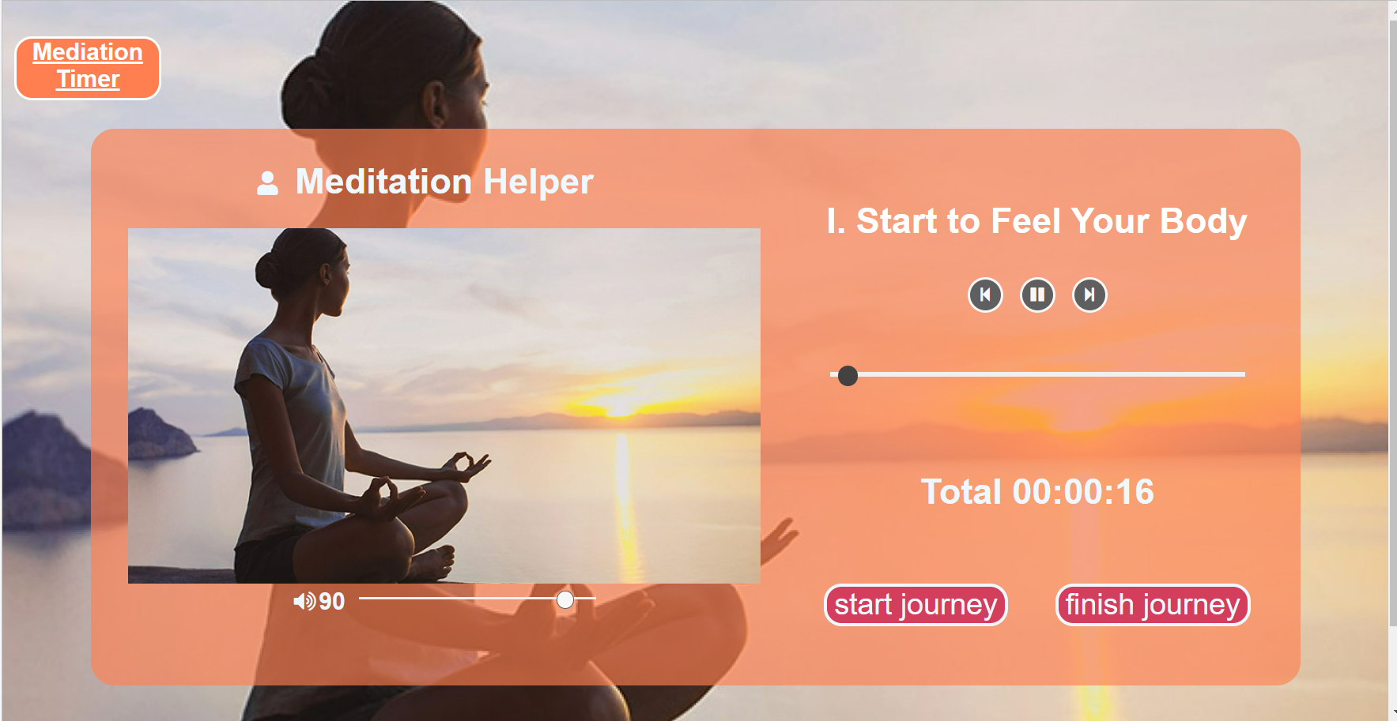 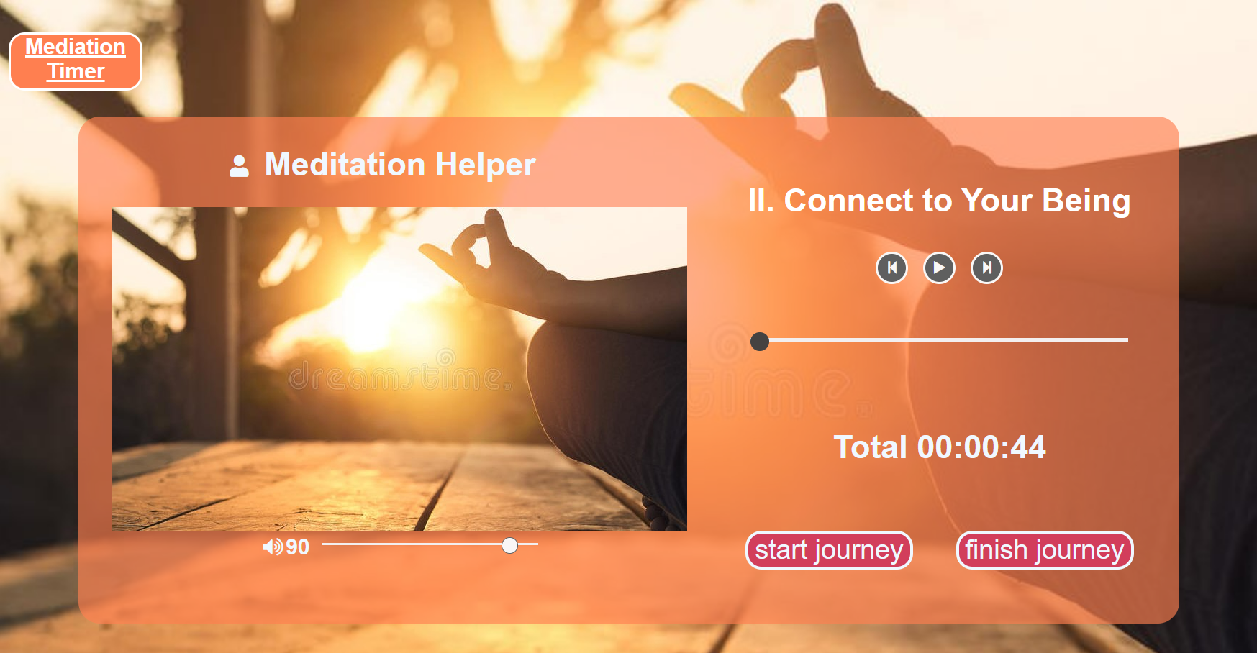 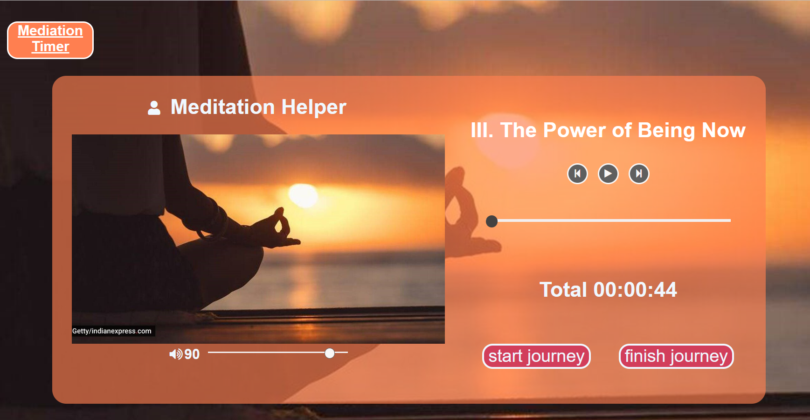

**If(track.ended())-> next_song()**

* 1. **Meditation Timer**: The Timer will keep the total playing time of the audio file, which is the meditation tutorial.



* 1. **Volume bar and Progress bar**: The two functions are how we can change the volume and the progress of the audio.

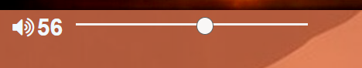 

* 1. **The “Finish Button”**: The auto-play function will be stopped and the timer will be reset.

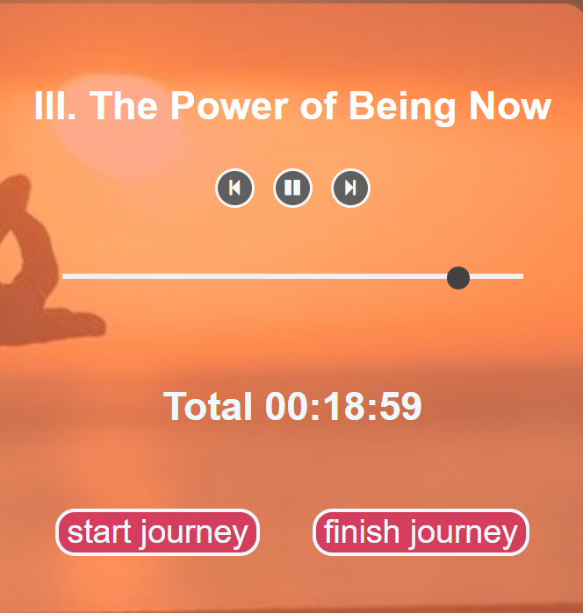 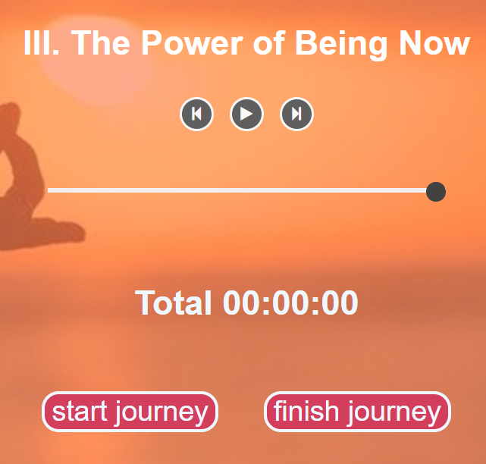

* 1. **Switch Page**:

 

* 1. **How to use the Timer?**

Press “start” >Click “hr” choose the hr of Meditation Time >Click “Min” choose the min of Meditation Time >Press “Confirm”> Start Mediation until the Timer Rings > The Record will show how long the user has meditated and keeps the dates.

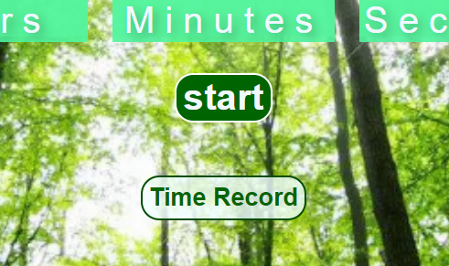 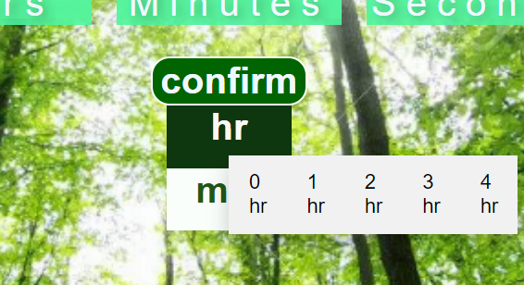 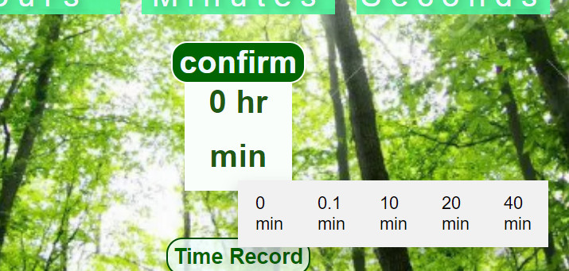 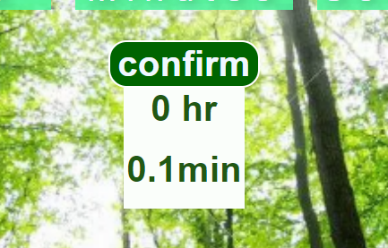 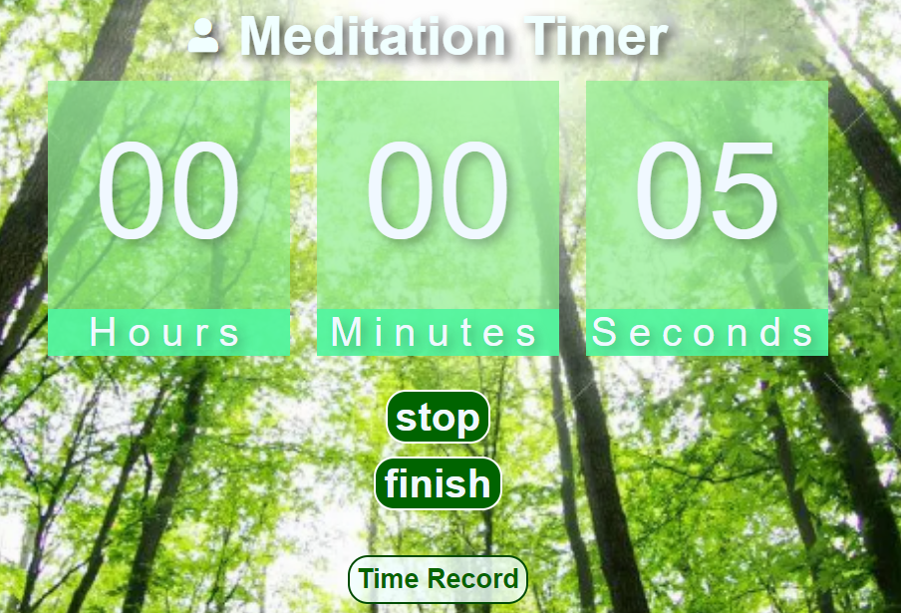 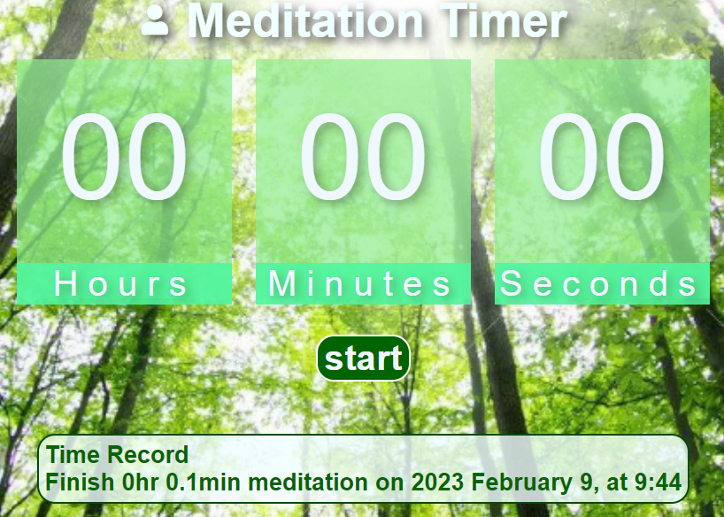

* 1. **The fool-proof function**: Users must both choose “Min” and “Hr” before starting meditation, If the users forget to choose one of them, the countdown timer won’t start and will show a warning message.

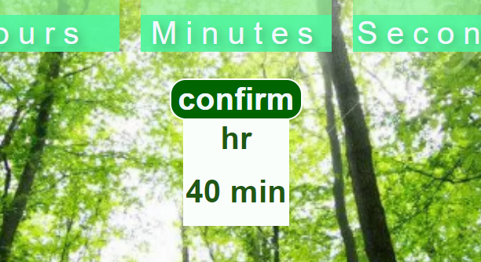 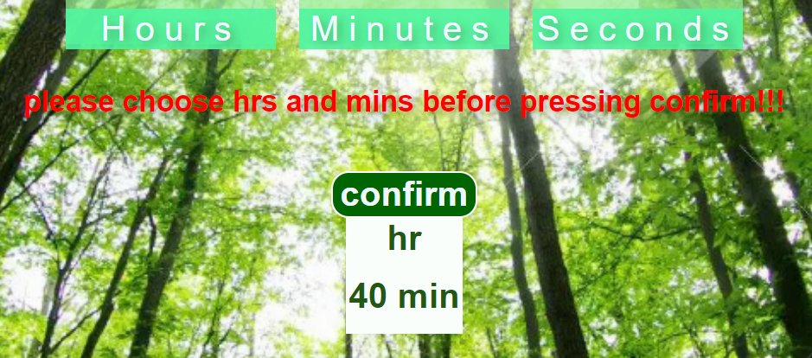

* 1. **The Meditation Record**: If the user has meditated until the countdown timer rings, the Record will be added to the box below.

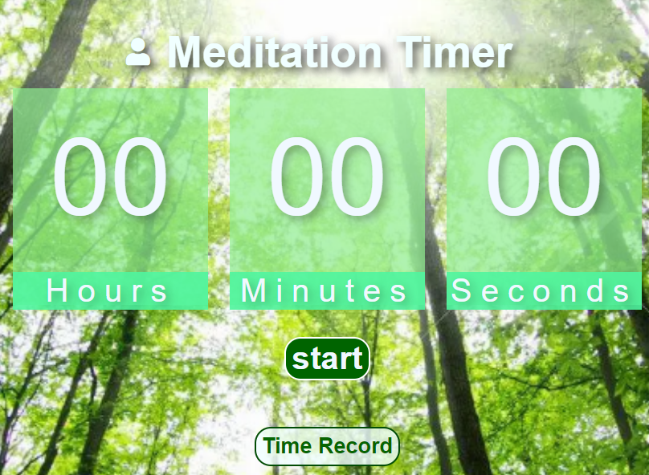 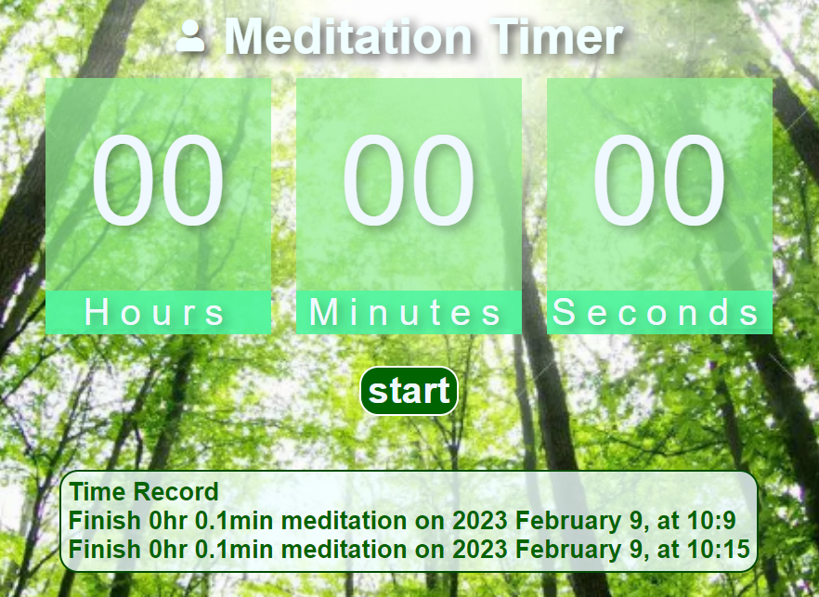

* 1. **“Stop”, “Resume”, and “Finish” buttons.**

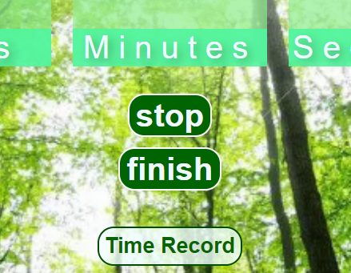 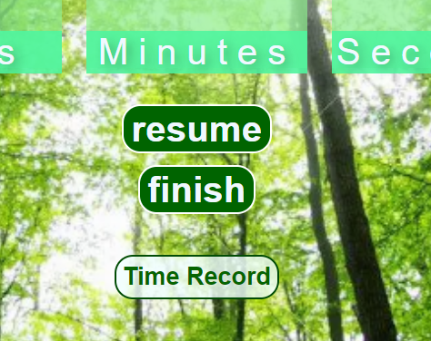

**Stop counting down**

**Keep counting down**

1. **Main difficulties and solutions**
   1. **Playing audio file:** We must use track.load() before using track.play(), or the audios can’t be played.
   2. **Switching the pictures, backgrounds, audio files, and titles while pressing “next_song()”:**
      1. using an array to store all the information, and change the index while pressing “next_song()”, and using load_data(track_ct) to load thepictures, backgrounds, audio files, and titles.
      2. Setting the background images on js file: doucument.body.style.backgroundImages=”url(‘picture_name.jpg’)”
   3. **Keep a function running once per second while certain events happen**

Run the functions: let int=setInterval(function,1000); //1000 milliseconds

Stop the function: clearInterval(int);

* 1. **How to show certain buttons while certain events happen**
     1. On html using style=”display:none”;
     2. On js, when certain functions are triggered, change the style of the object by using: document.getElementById(“Id_name”).style.display=”flex”
  2. How to make a drop-down menu:
     1. write the menu part on html, but using style=”display:none”;

<div onclick="sub_Function_min()" style="display:none;" id="dropbtn_min">min</div>

            <div class="set_position">

                <div id="sub_dropdown_min" class="dropdown-content_min">

                  <p onclick="f5_min()">0 min</p>

                    <p onclick="f1_min()">0.1 min</p>

                    <p onclick="f2_min()">10 min</p>

                    <p onclick="f3_min()">20 min</p>

                  <p onclick="f4_min()">40 min</p>

              </div>

          </div>

* + 1. On js, when certain functions are triggered, change the style of the object by using: document.getElementById(“Id_name”).style.display=”flex”

function sub_Function_min() {

    document.getElementById("sub_dropdown_min").classList.toggle("show");

}

function sub_Function_hr() {

    document.getElementById("sub_dropdown_hr").classList.toggle("show");

}